Exercise 1: Mirroring Configuration
Step 1.Create the mirroring configuration on the Primary node (irisa). Specify the arbiter address and port.
1, Enable mirror service
On irisa, go to System Management
Portal(http://127.0.0.1:8081/csp/sys/Utilhome.csp) >System
Administration>Configuration>Mirror Settings>Enable Mirror Service Check “Service Enabled” and click Save.
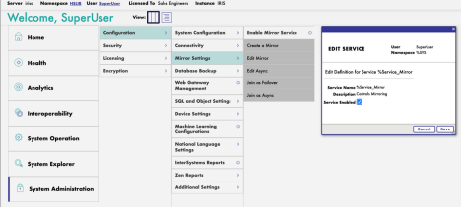2, Click “Create a Mirror”
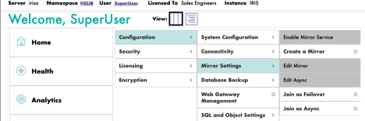In the page:
Input “Mirror Name” a name like IRISMIRROR
Uncheck “Require SSL/TLS” since we don’t setup SSL/TLS yet
Check “Use Arbiter”, and input “Address” as “arbiter”
Keep all others as default value
Click Save to save the mirror setting.
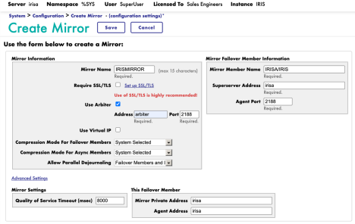3, Check mirror status on irisa
Go to System Management Portal > System Operation > Mirror Monitor Should see status like below:
Only one mirror member in the list, IRISA/IRIS, as Primary node;
Aribter connected with address arbiter|2188.
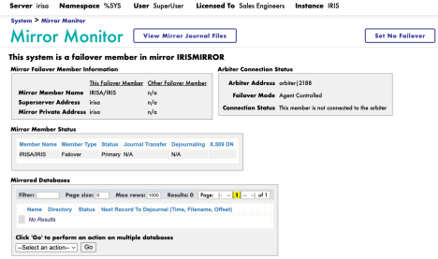
Step 2. let Backup node (irisb) join the mirror cluster
1, Enable mirror service
On irisb, go to System Management Portal
(http://127.0.0.1:8082/csp/sys/Utilhome.csp)>System
Administration>Configuration>Mirror Settings>Enable Mirror Service Check “Service Enabled” and click Save.
2, Join the mirror cluster
Select “Join as Failover”
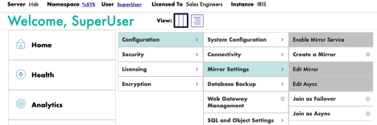and enter:
“Mirror Name” as IRISMIRROR
“Agent Address on Other System” as the hostname of primary node, which is irisa “Agent Port” as iscagent port number on the primary node, which is 2188
“InterSystems IRIS Instance Name” as IRIS instance name on the primary node, which is IRIS
Click Next.
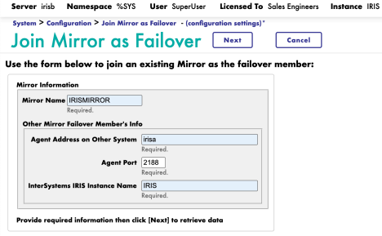
Confirm and Save:
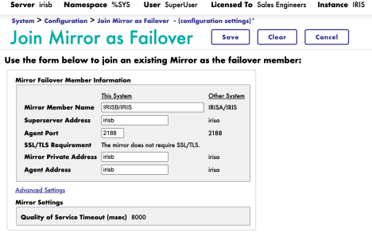3, Check mirror status on irisb
Go to System Management Portal > System Operation > Mirror Monitor Should see status like below:
Now two mirror members in the list: IRISA/IRIS as Primary node; IRISB/IRIS as Backup node.
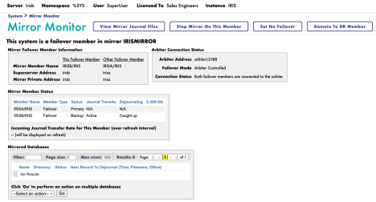Congratulation, your failover mirror cluster is now ready!
Exercise 2: Add Database into Mirror
Notice, “Mirrored Database” list is empty. It’s because that we did not assign database to be mirrored yet.
You can create a new database on both nodes and assign it as mirrored database, and also can add a existing database on primary node as mirrored database. We will exercise both cases.
2.1 Create a new mirrored database
Step 1: Add new mirrored database on Primary node
On the Primary node (irisa), create a new database named as “mymirrordb”, and change “Mirrored database?” to Yes, keep “Mirror DB Name” as the auto-populated name unchanged (MYMIRRORDB).
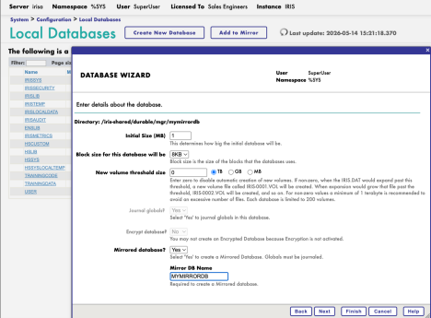Click Finish. Now you can see this database added as mirrored database: 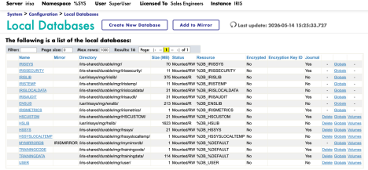And on Mirror Monitor page:
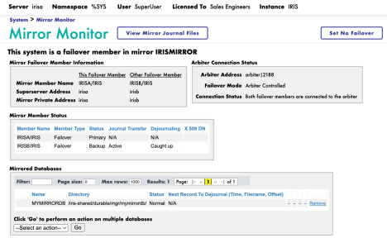
Step 2: Add same named new database on backup node
First, take a look on Mirror Monitor page of backup node:
There is a warning “Missing Mirrored Database Report”
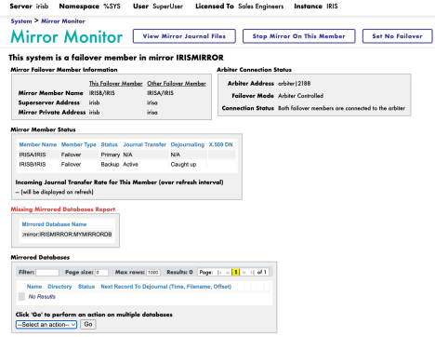
Now, on the Backup node, create a new database with the same name (MYMIRRORDB) and exact same setting of the primary one:
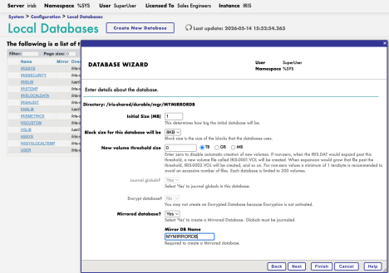
Step 3: Check status
On either node, go to Mirror Monitor, should see status like below:
Backup node should be on status of Caught up
Mirrored database should be on status of Dejournaling on backup node
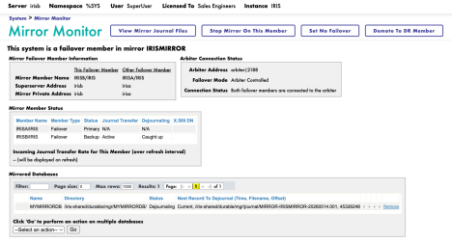
Step 4: Verify that it works
Now, write some data in the Primary node, and verify it’s sync to the Backup node. On irisa terminal, change to mymirrordb database with command: zn "^^/iris shared/durable/mgr/mymirrordb/" which is the folder of the database file.
Run s ^Test(1)="Hello"
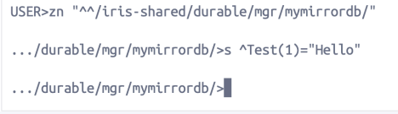
Go to irisb> System Management Portal>System Explorer>Globals, change “Look in:” as Database/MYMIRRORDB. Now should see the global ^Test:
2.2 Add existing database as mirrored database
Yesterday, we created a namespace “training” and 2 databases, trainingcode and trainingdata on irisa. Let’s add trainingdata as mirrored database.
Step 1: Add existing database as mirrored database on Primary node
On primary node (irisa), goto System Management Portal>System Administration>Configuration>System Configuration>Local Databases, click trainingdata, and then click “Add to Mirror IRISMIRROR”, and click “Add”.
Now the database is added as mirrored database, but on backup node, you will see same “Missing Mirrored Database Report” warning for this database.
Step 2: Add this database on backup node
On backup node (irisb), there are serveral ways to do it:
1. If the database is not too big, just create a database with same name and set “Mirrored database?” to Yes. After save, irisb will automatically download the database file from primary node (irisa).
2. If the database is too big, there are 2 ways to resolve:
a. Restore the database on backup node (irisb)
b. Dismount the database on primary node, and then copy the database file to target folder on backup node (irisb), and create a same named
database from this folder. After that, mount the database on primary node.
You can do the exercise with any way. Let us know your result.
Exercise 3: Failover test
Step 1: Stop IRIS on primary node (irisa)
Goto primary node (irisa) terminal, run: iris stop iris
Step 2: Observe the failover
Observe the Mirror Monitor on backup node (irisb) and verify it has become the primary node.
Access from haproxy port (8080) http://127.0.0.1:8080/csp/sys/Utilhome.csp,observe it’s the portal of irisb:
Step 3: Start iris on irisa
Start iris instance on irisa: iris start iris
Observe irisa now added into mirroring cluster as backup node automatically.

